Market Monitor - Syria - 2026-01

Highlights
The Syrian market remains volatile, with a broad year-on-year deflationary trend for key commodities. However, recent severe climate events are anticipated to exert significant upward pressure on prices in affected regions.
The average food basket cost in January 2026 stood at SYP 15,475.1, showing a slight month-on-month increase of ↑0.3% but a significant year-on-year decrease of ↓14.0%.
- Sugar prices experienced a marginal month-on-month increase of ↑0.8%, alongside a substantial year-on-year decrease of ↓14.4%.
- In contrast, Wheat flour saw a slight month-on-month decrease of ↓0.4%, while still registering a significant year-on-year decrease of ↓13.5%.
Key Market Drivers:
- Climate events and natural disasters (wildfires, snowstorms)
- Disruptions to agricultural output and supply chains
- Humanitarian needs and displacement impacting demand for basic goods
- Underlying economic pressures and historical inflation/deflation trends
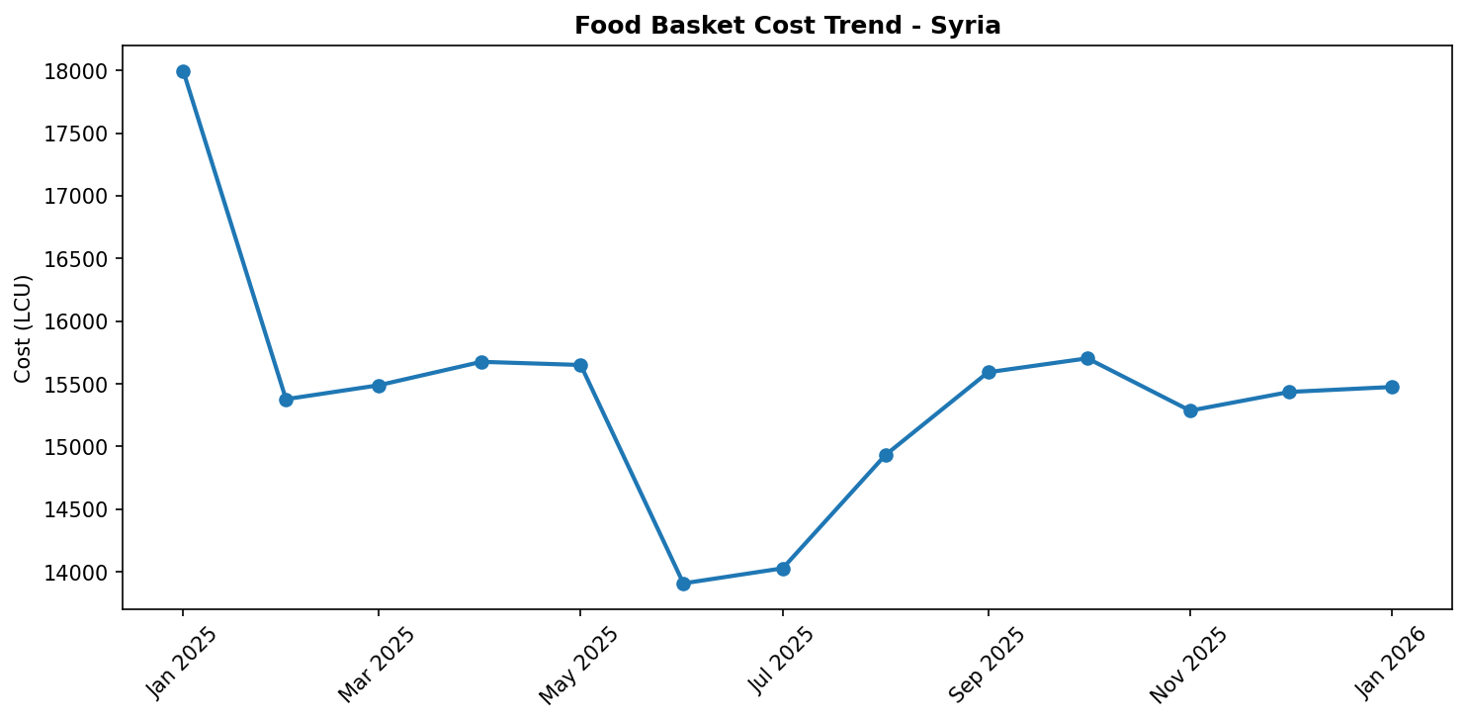
Food basket cost trend

Market Overview
The Syrian market in January 2026 continues to exhibit a volatile trajectory, grappling with the compounding effects of severe climate events against a backdrop of underlying economic pressures. While broader year-on-year statistics indicate a significant deflationary trend for key commodities, recent devastating wildfires in Western Syria (July 2025) and a harsh snowstorm in Northern Syria (December 2025) are poised to exert considerable upward pressure on prices. These natural disasters have emerged as dominant market drivers, leading to substantial disruptions in agricultural output and crucial supply chains. Concurrently, heightened humanitarian needs and large-scale displacement continue to impact demand for basic goods, creating a complex interplay of factors. Historical inflation and deflation trends also contribute to the market's current instability. For the immediate future, this dynamic environment is expected to translate into increased localized price volatility, particularly affecting food, shelter, and basic necessities in the most impacted regions, potentially overriding the observed short-term stability or minor month-on-month changes.

Commodity Analysis
Analysis of key commodities reveals a nuanced picture, with significant year-on-year price reductions suggesting a period of broader market stabilization, yet recent month-on-month shifts hint at emerging pressures. The Food Basket recorded a substantial year-on-year decrease of -14.0%, indicating a general reduction in the cost of essential goods compared to the previous year. However, a slight month-on-month increase of +0.3% signals recent upward price adjustments or a stabilization after previous declines, potentially reflecting localized impacts of recent events. Similarly, Sugar prices demonstrate a notable year-on-year decrease of -14.4%. A marginal month-on-month increase of +0.8% aligns with the overall trend, indicating a slight recent upward adjustment following a period of annual decline, suggesting a tentative recalibration of prices. In contrast, Wheat flour experienced a strong year-on-year decrease of -13.5%. Uniquely, it registered a slight month-on-month decrease of -0.4%. This distinct trajectory suggests that despite the broader disruptive context, wheat flour may be experiencing continued downward pressure or more stable supply dynamics compared to other food items, potentially due to successful interventions or existing stockpiles cushioning immediate shocks. The overall commodity landscape remains susceptible to the escalating impacts of recent climate-related disruptions.
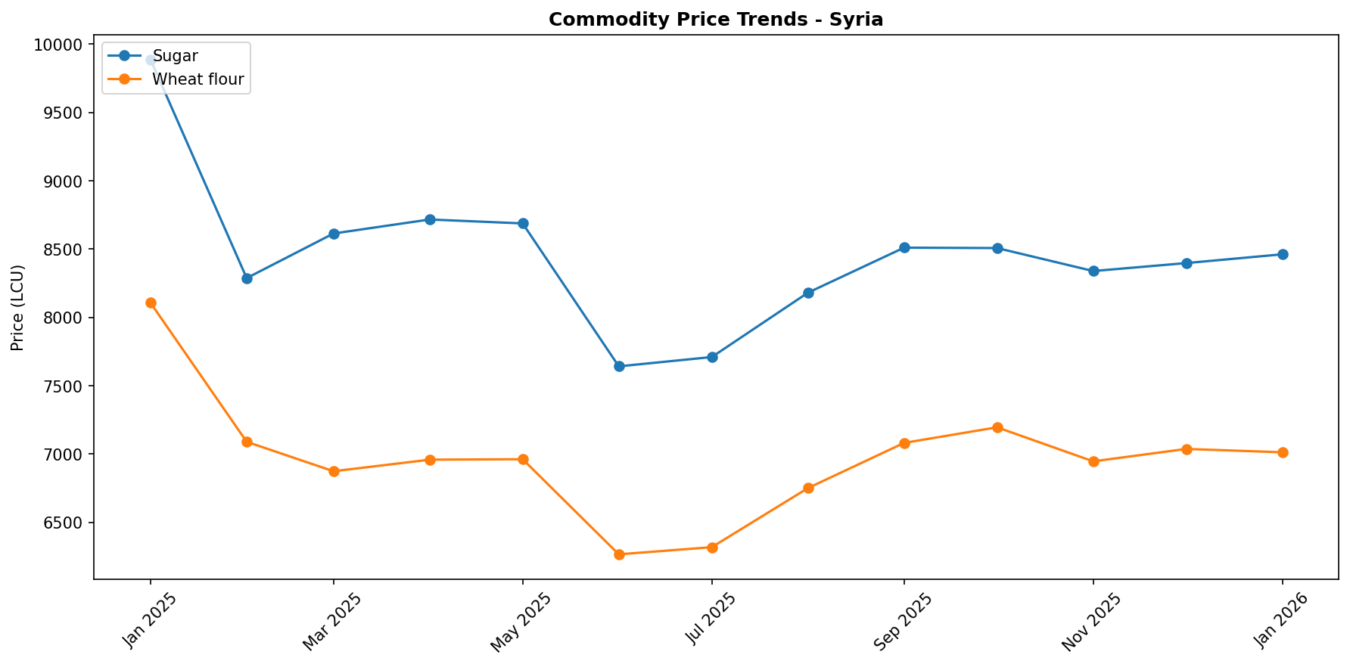

Regional Highlights
Regional disparities remain pronounced, largely driven by the localized and severe impacts of recent climate events. Western Syria, encompassing Lattakia, Tartous, Homs, Hama, and Idleb, continues to recover from the devastating wildfires in July 2025. This catastrophe likely inflicted significant damage to agricultural lands, led to population displacement, and severely disrupted local supply chains, exacerbated by difficult terrain and unexploded ordnance. Consequently, localized price increases for food, shelter, and other necessities are highly probable due to reduced supply and heightened demand in these affected areas. Further north, Northern Syria, particularly Aleppo, Idleb, and Al-Hasakeh governorates, was severely impacted by a snowstorm on December 31, 2025. This event, which damaged approximately 5,000 shelters and tragically led to two infant deaths in Harim, significantly increased the vulnerability of displaced populations within 90 IDP sites. Prices for essential winter goods, including heating fuel, warm clothing, and shelter materials, are expected to surge due to a sharp increase in demand and potential transportation disruptions, further exacerbating the dire humanitarian situation.
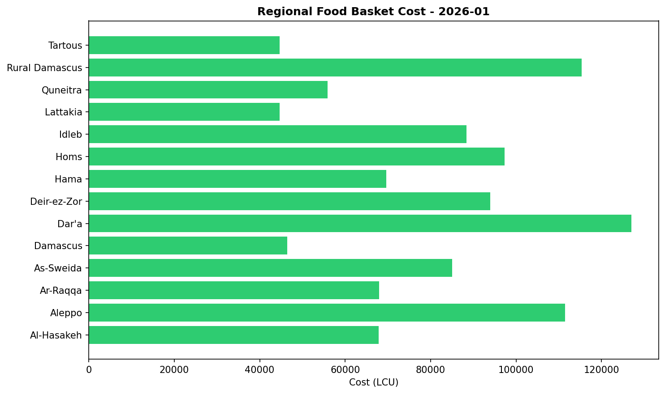

References
- [rw_4193733] ReliefWeb (2026-01-09) Syrian Arab Republic Fire 2025: DREF Operational Update (MDRSY015), January 2026
https://reliefweb.int/node/4193733
- [rw_4193579] ReliefWeb (2026-01-08) 10 conflictos para tener en la mira en 2026
https://reliefweb.int/node/4193579
- [rw_4193578] ReliefWeb (2026-01-08) 10 Conflicts to Watch in 2026
https://reliefweb.int/node/4193578
- [rw_4193405] ReliefWeb (2026-01-07) UNHCR Yemen Protection Brief 2025
https://reliefweb.int/node/4193405
- [rw_4193357] ReliefWeb (2026-01-06) Syrian Arab Republic: Flash Update No. 1 - Heavy Snowfall Hits Displaced Communities in Northern Syria (as of 6 January 2026)
https://reliefweb.int/node/4193357
- [rw_4193248] ReliefWeb (2026-01-05) Priority countries: Belgium, Germany and Norway’s contributions through the Special Fund for Emergency and Resilience Activities (SFERA)
https://reliefweb.int/node/4193248
- [rw_4193242] ReliefWeb (2026-01-05) QRCS enhances prosthetic, cancer diagnosis services in Syria [EN/AR]
https://reliefweb.int/node/4193242
- [rw_4193196] ReliefWeb (2026-01-05) Winterization Needs Assessment - Idleb and Aleppo Governorates (January 2026)
https://reliefweb.int/node/4193196
- [rw_4193176] ReliefWeb (2026-01-05) Syria Context Report, December 31, 2025
https://reliefweb.int/node/4193176
- [rw_4193078] ReliefWeb (2025-12-31) Syria: Joint Multi-Sectoral Needs Assessment (JMSNA) December 2025
https://reliefweb.int/node/4193078
- [gdelt_91926e41] GDELT (20260109) EU Launches New Era in Syria Relations
https://www.miragenews.com/eu-launches-new-era-in-syria-relations-1599747/
- [gdelt_bc650ba1] GDELT (20260109) Israel and Turkey are no longer feuding allies ; they are strategic rivals
https://www.middleeastmonitor.com/20260109-israel-and-turkey-are-no-longer-feuding-allies-they-are-strategic-rivals/
- [gdelt_f9b4c672] GDELT (20260109) Syria interested in adopting Azerbaijan SME house model [ PHOTO ]
https://www.azernews.az/nation/252762.html
- [gdelt_003b6099] GDELT (20260109) Somaliland recognition : Israel foothold in the Horn of Africa
https://www.yahoo.com/news/articles/somaliland-recognition-israel-foothold-horn-075138163.html
- [gdelt_6876d0d7] GDELT (20260109) Somaliland recognition : Israel foothold in the Horn of Africa - Dominican Republic Post – Caribbean News , Business , Travel & Culture
https://dominicanrepublicpost.com/somaliland-recognition-israels-foothold-in-the-horn-of-africa/
- [gdelt_ca116455] GDELT (20260109) Alexander Gur - Arie : Iranian army could side with people , IRGC more motivated to defend regime – INTERVIEW
https://news.az/news/-alexander-gur-arie-iranian-army-could-side-with-people-irgc-more-motivated-to-defend-regime-interview
- [gdelt_552445b9] GDELT (20260109) Weekly Sanctions Update : January 7 , 2026
https://www.mondaq.com:443/unitedstates/export-controls-trade-investment-sanctions/1728858/weekly-sanctions-update-january-7-2026
- [gdelt_6f1f75f5] GDELT (20260109) Sanctions Update : January 7 , 2026
https://www.mondaq.com:443/unitedstates/export-controls-trade-investment-sanctions/1728834/sanctions-update-january-7-2026
- [gdelt_090bcdff] GDELT (20260109) Roaming Charges : In ICE Cold Blood
https://www.counterpunch.org/2026/01/09/roaming-charges-125/
- [gdelt_66aa2049] GDELT (20260109) The Region in Brief
https://armenianweekly.com/2026/01/08/the-region-in-brief-152/

